SOFTWARE REQUIREMENTS SPECIFICATION
Health & Fitness Application

Project Summary
The Health & Fitness Application is a comprehensive digital platform designed to help individuals track, manage, and improve their physical health and fitness goals. The system enables users to monitor daily workouts, nutritional intake, body metrics, sleep patterns, and overall wellness through an intuitive mobile and web interface.
The application leverages data analytics and AI-powered recommendations to provide personalized fitness plans, dietary guidance, and progress reports. It reduces the need for physical trainers and nutritionists for basic fitness management, saving time and cost for health-conscious individuals.
Project Scope
The Health & Fitness Application provides a secure, scalable platform for multiple user roles including regular users, fitness coaches, and administrators. The system covers the following core functional areas:
- User registration, profile management, and goal setting
- Workout plan creation, scheduling, and tracking
- Nutrition logging with calorie and macro-nutrient tracking
- Body metrics tracking (weight, BMI, body fat percentage)
- Sleep and water intake monitoring
- Progress analytics with charts and milestone achievements
- Coach-to-user communication and plan assignment
- Integration with wearable devices and third-party fitness APIs
The application targets health-conscious individuals aged 16 and above, fitness coaches, gym instructors, and healthcare professionals seeking a digital tool for client management

Types of Users / Actors
The application supports three primary user roles, each with distinct permissions and capabilities:
- Administrator — Full system control, user management, and platform configuration
- Coach / Trainer — Client management, custom plan creation, and progress monitoring
End User / Member — Personal fitness tracking, goal setting, and plan execution

Administrator Features
- Manage user accounts: create, edit, suspend, or delete users and coaches
- Assign or revoke coach privileges and certifications
- Monitor platform-wide analytics: active users, engagement, subscription revenue
- Configure fitness categories, exercise libraries, and food databases
- Send platform-wide notifications and announcements
- Manage subscription plans and payment gateway configurations
- Generate audit logs and system health reports
- Integrate and manage third-party APIs (e.g., wearable device APIs, nutrition databases)
Coach / Trainer Features
- Create and manage personalized workout and nutrition plans for clients
- Monitor client progress, streaks, and goal completion rates
- Schedule virtual check-in sessions and send motivational messages
- Upload custom exercise videos and instructional content
- Set weekly targets and milestones for each client
- View detailed client body metrics and health history
- Generate progress reports in PDF format for client review
End User / Member Features
- Register, set up profile, and define fitness goals (weight loss, muscle gain, endurance, etc.)
- Browse and follow pre-built or coach-assigned workout plans
- Log daily workouts with sets, reps, duration, and calories burned
- Track nutritional intake using barcode scanner or manual entry
- Monitor body metrics: weight, BMI, body measurements over time
- View real-time and historical progress via interactive charts
- Earn badges and achievement milestones to stay motivated
- Connect wearable devices (Fitbit, Apple Watch, Garmin) for automatic data sync
- Set daily reminders for workouts, water intake, and meals
Access community forums and challenge boards.

User interface Design
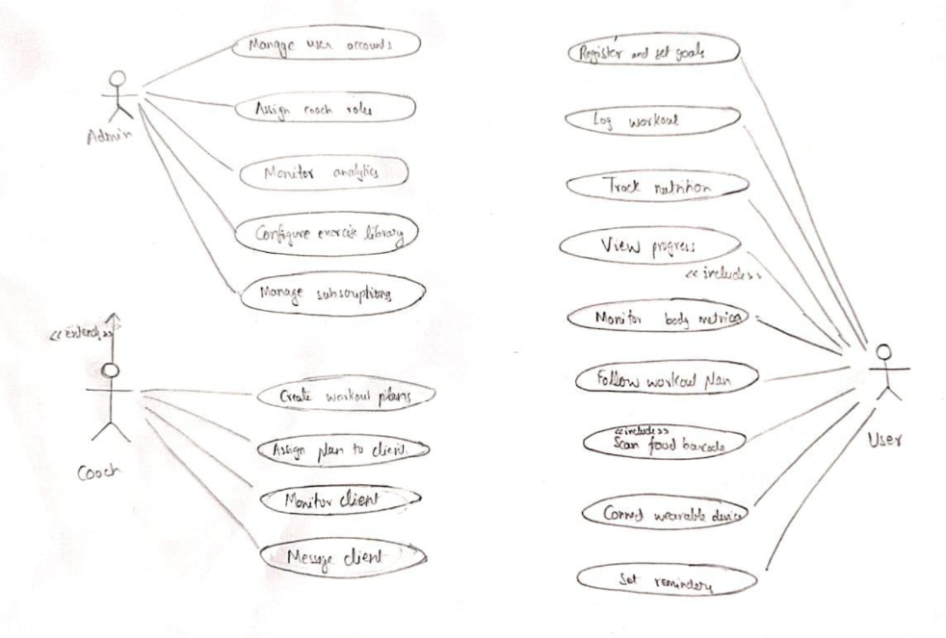

TEAM MEMBERS:
B.ASHISH
ROLL NO:AM.SC.U4CSE25309
PORTFOLIO WEB: https://ashishb5708.github.io/UID-Project-Portfolio/

E.SAHITH
ROLL NO:AM.SC.U4CSE25315
PORTFOLIO WEB: https://sahithdebug.github.io/My-Portfolio/

R.VEDA NANDA REDDY
ROLL NO:AM.SC.U4CSE25343
PORTFOLIO WEB: https://vedananda007.github.io/vedananda-mywebsite/

V.THARUN
ROLL NO:AM.SC.U4CSE25357
PORTFOLIO WEB: https://tarunv25357.github.io/UID-Project-Portfolio/

B.HARDHIK
ROLL NO:AM.SC.U4CSE25308
PORTFOLIO WEB: https://agenthardhik.github.io/portfolio/

